Name: _______________________________ Date:_______________
T: Counting on in 2’s
Practise ‘skip counting’ and fill in the missing numbers in the grid below.
Use a coloured pencil or pen, so you can see the pattern of 2’s.
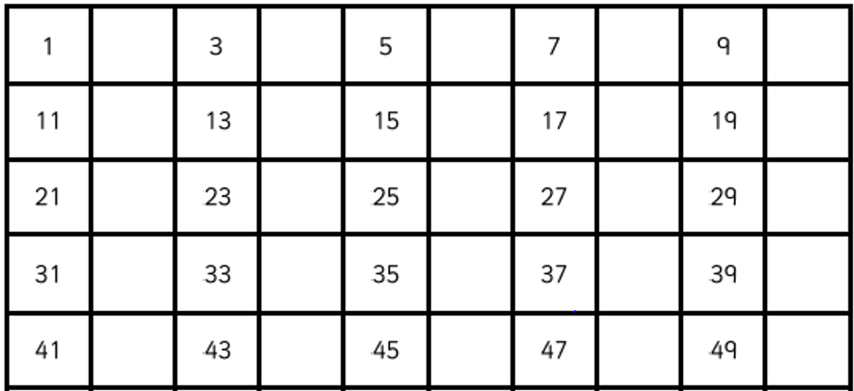
Fill in the missing numbers in the sequences.
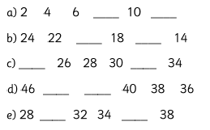
Be careful some sequences are counting forwards and some are counting backwards!

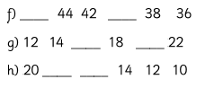

Challenge: How far can you count in 2’s?

